Tutorial 1b: Introduction to Database Systems

Objective: Understand the differences between the file-based processing and the database processing.

- In a hardware shop, computer systems were developed using traditional file-based approach. Each application program was designed to meet the needs of a particular requesting department or user group. The system overview diagram below shows the programs and files involved for Order Filling, Invoicing and Payroll Systems.
(Note: Each program is different. ie Program A in Order Filling is different from Program A in Invoicing and Payroll)

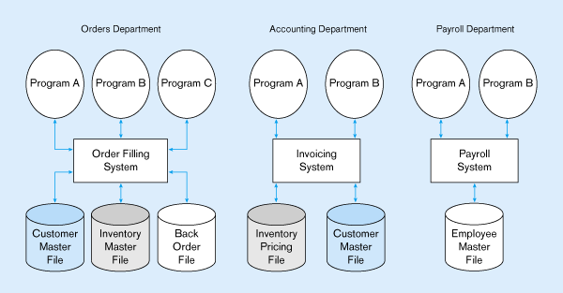

Answer the following questions based on the above scenario:

i Where is the data definition stored for each file?
ii Which are the duplication data files?
iii If we include a new data item called ‘customer preferences’ in Customer Master, which are the programs likely to be affected?

- The shop owner has decided to convert the above file-based systems to database systems due to the limitations of file-based systems.

i Propose a new system overview diagram.
ii Where is the data definitions stored for each file?
iii Is there any duplicate data files in the database?
iv If we were to include another new data item called ‘customer ranking’ in Customer Master, which are the programs likely to be affected?
v How the database system helps to minimize the changes required?

- List any three advantages of using a database system and describe how each of the advantages can be achieved through the features provided by the DBMS.

